Breaking News !

More than 62,000 pounds of raw beef recalled ahead of Memorial Day Weekend.

Is Metal Contamination Related Issues costing you down time and $$$$ profits?

**If so call NPKLLC (614-716-9820)** to schedule an inspection. We will inspect your Grinder and Mixing Lines and provide you with a complete report with detailed recommendations.

Part of the evaluation is to determine the difference between the source and the cause. You will not be able to lower your Metal Contamination issues without also addressing the cause.

NPKLLC will perform the following:

* 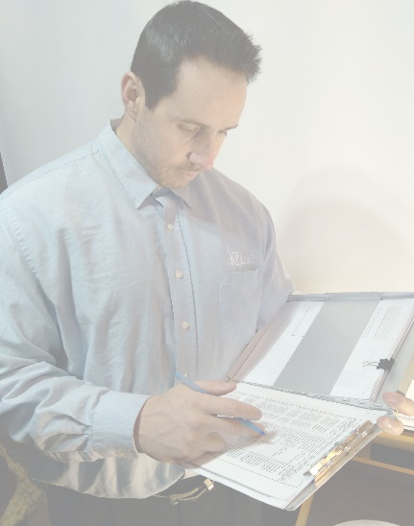Inspect the equipment.
* Review the QC records and inspect foreign particles.
* Watch the Assembly
* Watch the Start Up routines.
* Interview the Operators and Maintenance personnel.
* Document findings
* Create final report along with recommendations.

>>>>Flat rate fee quote plus expenses at cost<<<<

**Below are a few examples of the sources of Metal Contamination.**

**Metal Contamination related to typical Wolfking Grinding Lines**

